A: Natural selection and evolution
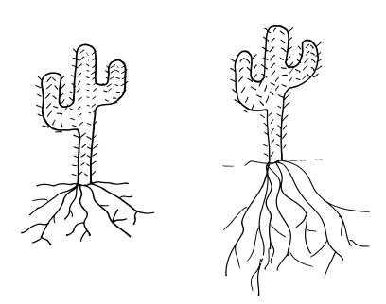
- Cacti are normally found in arid habitats where water is scarce and day temperatures are high.
After a period of 10 years of drought in an area, researchers discovered that the mean length of roots in a cactus population had increased.
In the 1800s, Darwin and another scientist called Lamarck had different theories to explain how the short roots of the cactus evolved into the longer present day roots of the cactus.
Lamarck had an idea that the root cells would have stretched during the lifetime of the cactus to reach more water. The stretched roots would then be passed on to the offspring.
- Explain Darwin’s theory of natural selection to explain how longer roots evolved. (4)
Variation occurs in the population / mutation
Longer rooted cacti get more water
And more survive during drought
Surviving cacti breed
Pass on genotype for longer roots to offspring
More of the population have longer roots
- Suggest one reason why scientists in the 1800s could not decide if Darwin or Lamarck was correct. (1)
Insufficient evidence available
Mechanism of inheritance not known
- The general public in the 1800s had a different idea which explained how all life on Earth came about. What was this idea? (1)
God made all living things / creationism
- Describe three reasons why Darwin’s theory of evolution by natural selection has now been widely accepted by everyone. (3)
Mechanism of inheritance now understood – characteristics are passed onto offspring in genes
Evidence in the fossil record
Knowledge of how resistance to antibiotics evolves in bacteria

- Explain how working with bacteria and antibiotics has helped scientists learn more about evolution. (4)
Bacteria reproduce rapidly
Mutation of bacteria occurs and new strains produced
Mutation confers advantage to these bacteria and so they survive and reproduce
After a short period of time there are more resistant bacteria than non resistant bacteria (as they have been killed)
This happens so quickly evolution by natural selection can be observed in the laboratory.
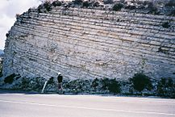
- Stratigraphy is a scientific study of rock layers (strata) and how they are layered.
- How could this knowledge be used in supporting evidence for human evolution? (2)
The deeper rock layers are older
Tools/fossils found deeper down are older than those found nearer surface
b) Why might this evidence not be accurate? (1)
Rock layers move/disrupted by earthquakes/building
c) Give three reasons why scientists concluded that Lucy (Australopithecus afarensis) was more human
like than Ardi (Ardipithecus ramidus). (3)
Arched feet in Lucy versus ape-like big toes in Ardi for grasping trees
Brain size larger in Lucy
Length of arms and legs are more like human in Lucy. In Ardi long arms and short legs more like an ape
Structure of leg bones in Lucy more like humans than in Ardi
d) A bat and a whale have both been found to have pentadactyl limb structures. Why is this an important piece of evidence for evolution? (2)
Two of:
Uses of the limb are very different but
Suggests a common ancestor that both have evolved from
Unlikely to have similar complex structures occurring by chance

B: Classification of living organisms
1 a) Both of the birds in the photograph are known as robins. Suggest two reasons why this could be a problem. (2)
They will not be able to interbreed
Possible confusion with accurate identification between scientists/ornithologists
Erithacus rubecula
Turdus migratorius

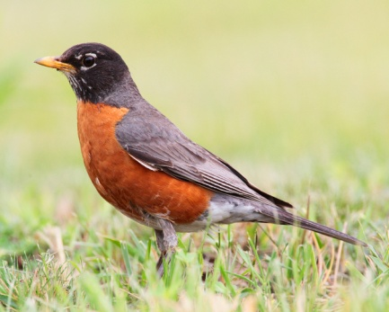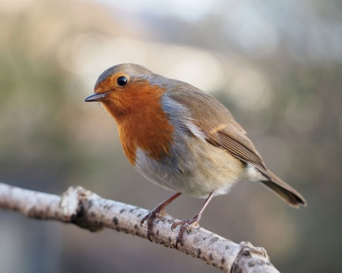

b) What information do the scientific names of the robins provide? (2)
Genus
Species
- Why can it be difficult to classify some living organisms? (2)
There is variation in all living organisms in the same species
Some organisms have very similar features that are common to more than 1 species/group

Carl Woese identified three distinct groups of organisms he called domains: Archaea, Bacteria and Eukaryota.

Feature | Archaea | Bacteria | Eukaryota
Type of chromosome | Circular | Circular | Linear
Number of protein molecules in RNA polymerase | 10 | 5 | 12
Cell membrane | Branched hydrocarbon chains attached to glycerol by ether bonds | Unbranched fatty acid chains attached to glycerol by ester bonds | Unbranched fatty acid chains attached to glycerol by ester bonds
Peptidoglycan present | No | Yes | Yes
Size of ribosomes | 70S | 70S | 80S

- Using the information in the table, give evidence that agrees with Carl Woese’s theory that archaea should be grouped separately to bacteria and eukaryota. (2)
Archaea does not have peptidoglycan
Archaea has a different arrangement of molecules in its cell membrane to bacteria and eukaryota.
- Woese put forward this simple evolutionary tree to show the relationships between the three domains. What has happened at points A and B on the diagram? (2)
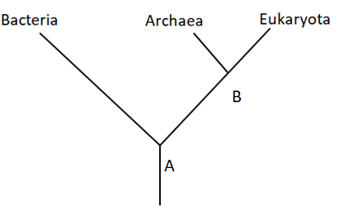
A = bacteria and B have evolved from the common ancestor
B = Archaea and Eukaryota have evolved from their ancestor B

- Which two domains are most closely related according to Woese? (1)
Archaea and Eukaryota (1)

C: Selective breeding, tissue culture and genetic engineering
- Explain how the human insulin gene and plasmids can be used to genetically modify bacteria. (4)
Four of:
Restriction enzymes are used to isolate the human insulin gene from human DNA
The bacterial plasmid/vector is cut open using restriction enzymes
The plasmid DNA and the human insulin gene have sticky ends
The human insulin gene is inserted into the bacterial plasmid using ligase enzyme
The plasmid with the inserted gene/recombinant DNA is placed into a bacterial cell
Bacteria reproduce and make human insulin
Rubbish-filled ditch beside roadside burger van named as one of UK’s 10 most important wildlife sites. Daily Mail.co.uk Feb 1, 2011.

2

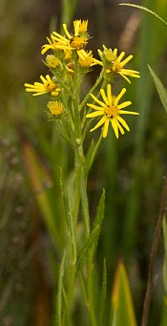
Extended response question
According to Natural England, this is the only place in the country where self seeded Fen Ragwort grows. It was thought to have become extinct in the Victorian era.
Describe the benefits and disadvantages of using tissue culture to preserve the species. (6)
- Level 3 (5-6 marks)
A detailed and coherent explanation is provided that considers a range of relevant points for both the benefits and disadvantages of tissue culture
Level 2 (3-4 marks)
Most relevant points made which cover both a benefit and disadvantage
- Level 1 (1-2 marks)
Some relevant points made with no logical structure
Indicative content
Benefits of tissue culture: uses small groups of cells from the plant
Many new genetically identical plants can be grown from a few cells
Only a small amount of damage to the parent plant occurs
Reliable as even if some cells do not grow others are likely to
Disadvantages:
Expensive- needs to be done in a lab/sterile conditions
Cannot be done by gardeners

- The photographs show a wild pig and a modern day pig known as the Large White.
The Large White is a descendant of the wild pig and has been produced by selective breeding. It is renowned for bacon production. The photographs are scaled to show the relative sizes.
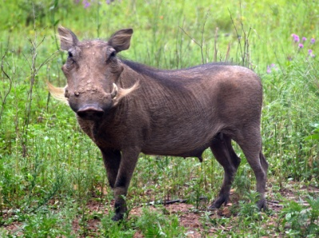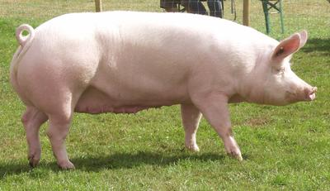
- Suggest two features you can see in the photograph that farmers selected for when breeding the Large White. (2)
No tusks
Colour of skin
Not much hair
Lots of meat/size
- Explain how a farmer could use selective breeding to breed pigs which are very docile in nature. (3)
Choose pigs which are the most docile to breed from.
In the next generation only choose docile pigs to breed from.
Carry this on for many generations until all the pigs in the herd are docile.

